## **WEEK 6: 3.ReactJS-HOL (Solutions)**

Estimated time to complete this lab: **30 minutes.**

Create a react app for Student Management Portal named scorecalculatorapp and create a function component named “CalculateScore” which will accept Name, School, Total and goal in order to calculate the average score of a student and display the same.

**Hands-on Solutions:**

* Create a React project named “scorecalculatorapp”.
* Create a new folder under Src folder with the name “Components”.
* Add a new file named “CalculateScore.js”

**CaclulatScore.js:**

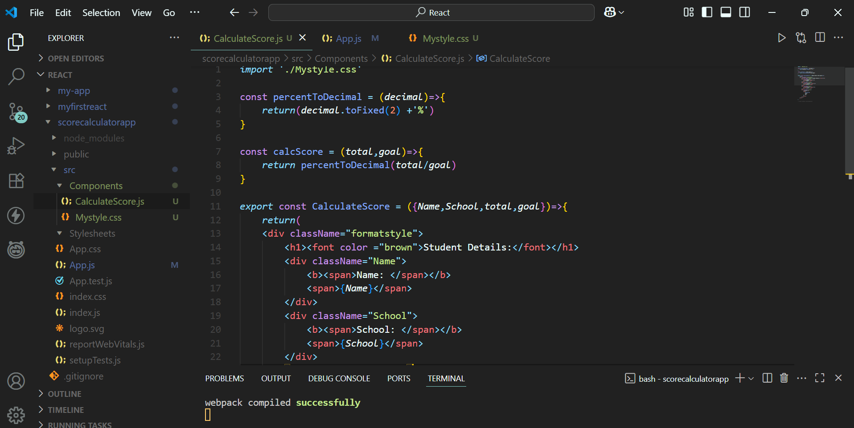

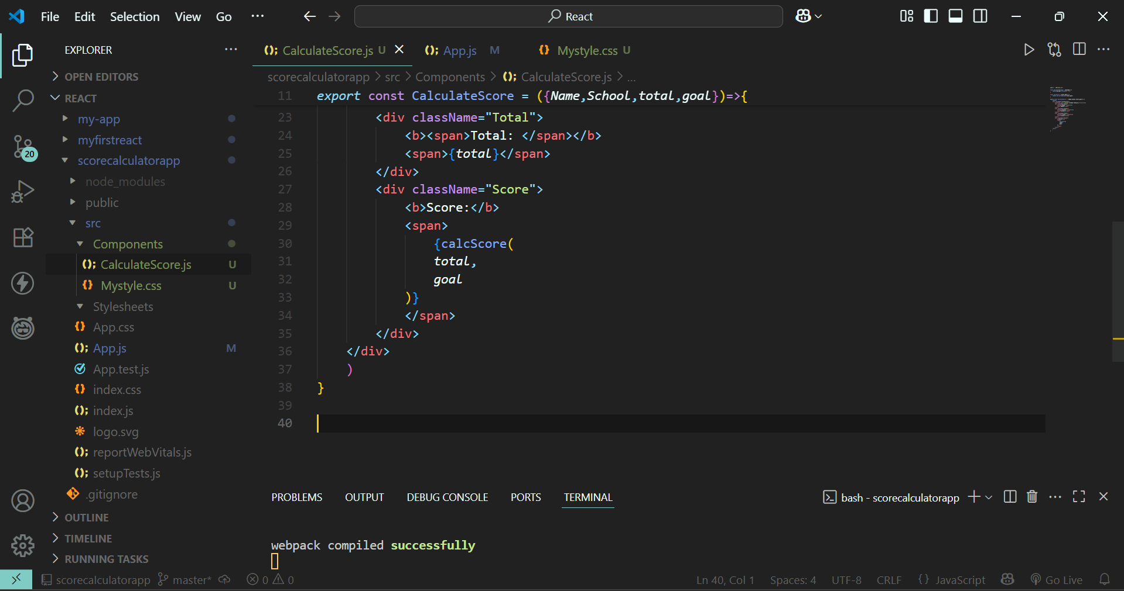

* Create a Folder named Stylesheets and add a file named “mystyle.css” in order to add some styles to the components:

**Mystyle.css:**

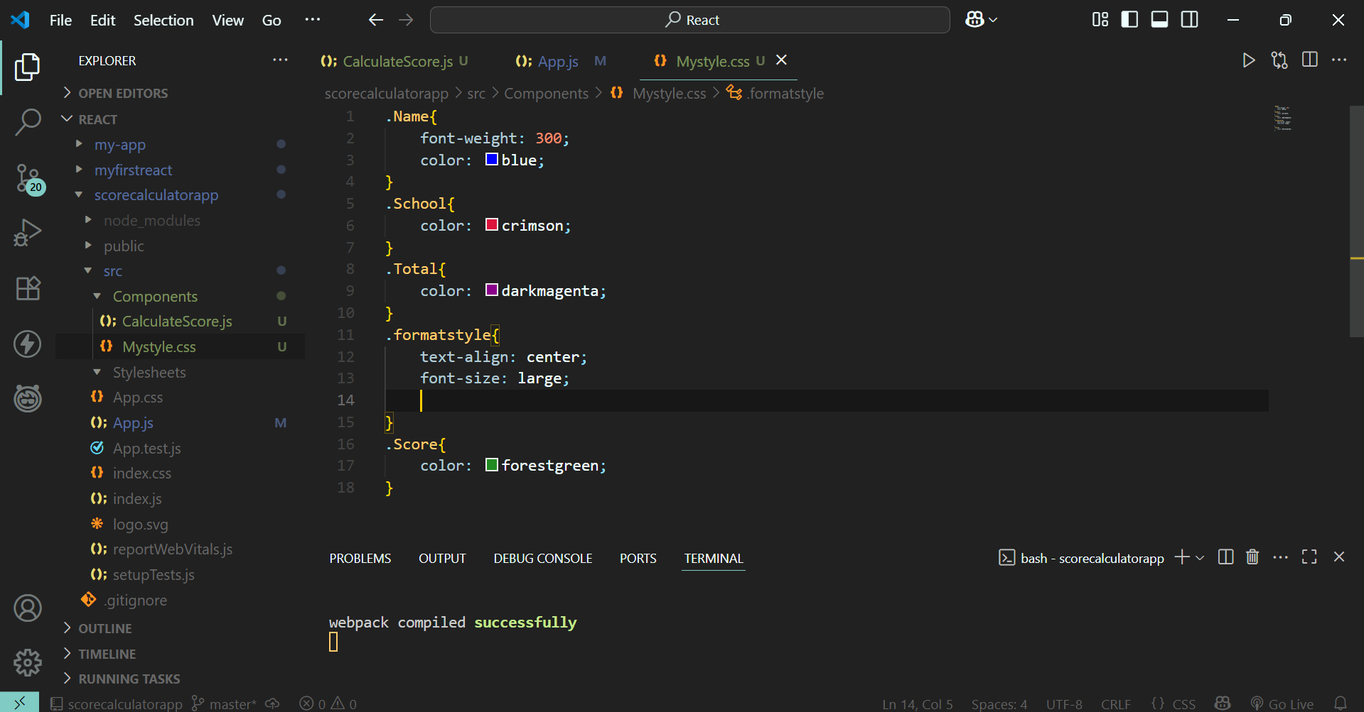

* Invoking the CalculateScore.js in the App.js file

**App.js:**

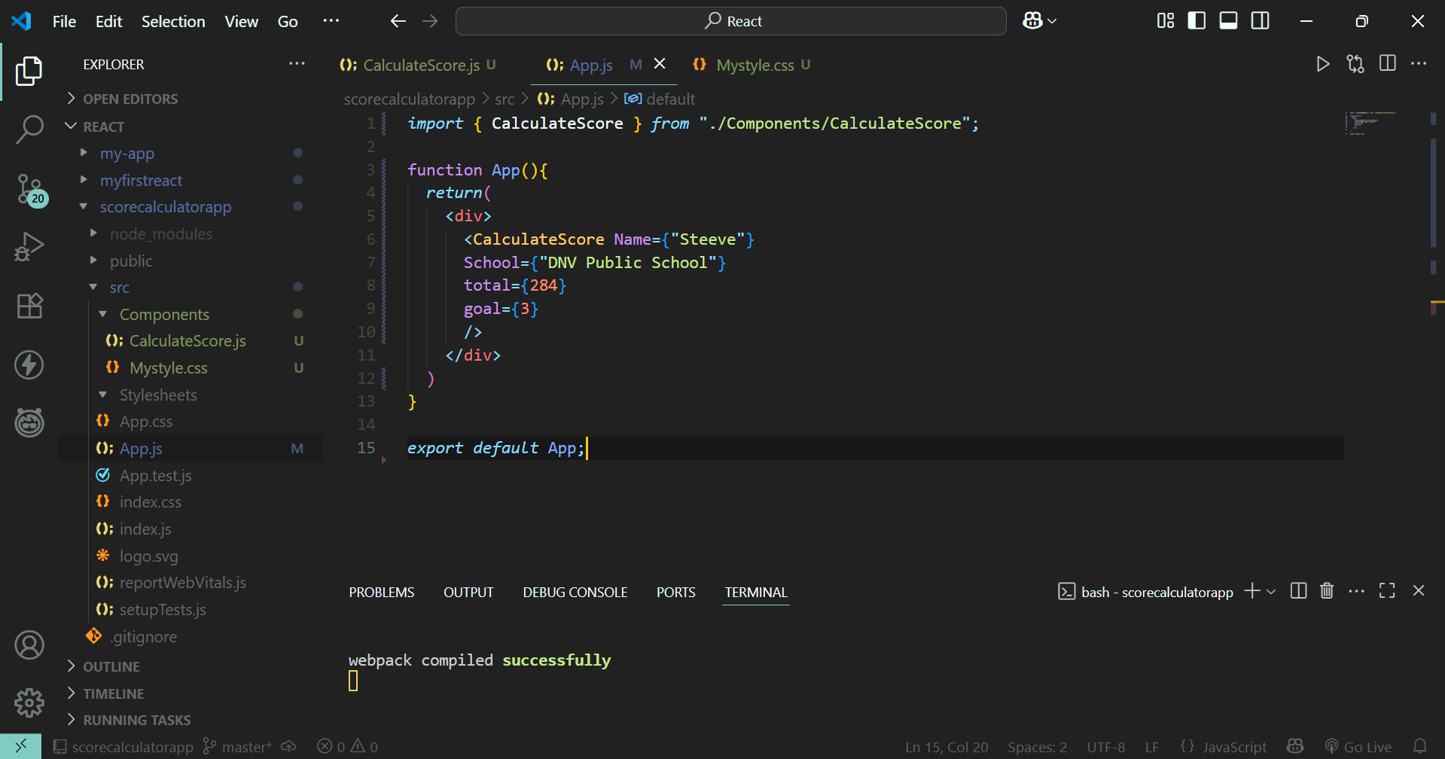

* Running the **scorecalculatorapp :**



